E-COMMERCE SALES & CUSTOMER ANALYTICS
End-to-End Data Analytics Project — Summary Report
Tools: Microsoft Excel | MySQL | Power BI | DAX
Workflow: Excel → MySQL → Power BI → DAX → Business Insights

1. Executive Summary
This project presents an end-to-end e-commerce data analytics solution using Microsoft Excel, MySQL, Power BI, and DAX. Raw customer, product, order, payment, and return data were cleaned, structured, analyzed, modeled, and transformed into interactive dashboards and business insights.
The final Power BI solution contains five pages covering executive performance, customers, products and sales, returns and payments, and business insights.

2. Project Objectives
- Clean and validate raw e-commerce datasets.
- Build a relational database and perform real-world SQL analysis.
- Create a connected Power BI data model.
- Develop DAX measures for business KPIs and time-based analysis.
- Build interactive dashboards for sales, customers, products, returns, and payments.
- Translate analytical results into business insights.

3. Dataset & Data Model
The project uses seven core tables: Customers, Products, Orders, OrderItems, Payments, Returns, and Calendar.
Table | Purpose | Approx. Rows
Customers | Customer master and geography | 1,003
Products | Product and pricing master | 142
Orders | Order-level transactions | 5,003
OrderItems | Order line details | 12,522
Payments | Payment transactions | 5,000
Returns | Returned order records | 520
Calendar | Time intelligence | 1,369

4. Excel Data Cleaning & Preparation
Excel was used as the initial data-preparation layer.
- Removed duplicates where appropriate and standardized text fields using Excel formulas.
- Validated CustomerID, ProductID, OrderID, and OrderItemID keys.
- Checked dates, quantities, prices, and missing values.
- Used XLOOKUP to validate product pricing.
- Calculated line-item Revenue as Quantity × UnitPrice.
- Prepared cleaned datasets for MySQL and Power BI.

5. MySQL Database & SQL Analysis
The cleaned data was loaded into the ecommerce_analytics_project database. Analysis included JOINs, subqueries, CTEs, window functions, ranking, running totals, moving averages, YoY/MoM analysis, customer segmentation, payment analysis, returns analysis, and customer-value analysis.

6. Power BI Data Model
- Customers[CustomerID] → Orders[CustomerID] (1:*).
- Orders[OrderID] → OrderItems[OrderID] (1:*).
- Products[ProductID] → OrderItems[ProductID] (1:*).
- Orders[OrderID] → Payments[OrderID] (1:*).
- Orders[OrderID] → Returns[OrderID] (1:*).
- Calendar[Date] → Orders[OrderDate] (1:*).

7. Key DAX Measures
Measure | Purpose
Total Sales | Total line-item revenue
Total Orders | Distinct order count
Total Customers | Distinct customer count
Total Products | Distinct product count
Average Order Value | Sales ÷ orders
Return Rate | Distinct returned orders ÷ orders
YoY Sales Growth % | Year-over-year sales change
MoM Sales Growth % | Month-over-month sales change
Sales per Customer | Sales ÷ customers
Repeat Customer % | Customers with more than one order
Average Items per Order | Quantity ÷ orders
Customer Lifetime Value | Historical CLV proxy
Running Total Sales | Cumulative sales
Average Monthly Sales | Average sales by YearMonth
Payment Success Rate | Completed payments ÷ total payments

8. Power BI Dashboard Pages

1. Executive Dashboard
Subtitle: Sales Performance | Customer Growth | Product Insights | Business KPIs
Overall sales, customers, products, regions, channels, orders, payments, and returns.

2. Customer Analytics Dashboard
Subtitle: Customer Segmentation | Revenue Analysis | Purchase Behavior | Regional Insights
Customer revenue, repeat purchasing, frequency, geography, and customer behavior.

3. Product & Sales Analysis
Subtitle: Product Performance | Category Trends | Sales Growth | Channel Analysis
Product, category, quantity, price-band, channel, status, and regional analysis.

4. Returns & Payments Analysis
Subtitle: Return Performance | Payment Insights | Transaction Status | Customer Impact
Return reasons/status, payment methods/status, payment success, and monthly trends.

5. Business Insights
Subtitle: Key Findings | Sales | Customers | Products | Returns | Payments
Management-oriented interpretation of the completed analysis.

9. Business Insights from the Completed Dashboard

Sales Performance
Total sales are approximately 1.27B, with average monthly sales of approximately 27.63M. Displayed YoY growth measures show 0.15% in 2024, -3.70% in 2025, and -1.78% in 2026.

Customer Insights
The dashboard shows 988 customers and a repeat customer rate of 59.62%. Sales per customer is approximately 254.41K, while the historical customer lifetime value proxy is approximately 1.29M.

Product Insights
Home & Kitchen and Beauty are the leading displayed categories at approximately 0.26B each, followed by Electronics at approximately 0.25B.

Sales Channel Insights
Website has the highest displayed sales at approximately 0.21B, followed by Mobile App at approximately 0.16B and Marketplace at approximately 0.10B.

Returns Insights
The dashboard shows 20 recorded returns. Damaged products are the most common displayed return reason with 6 cases, followed by Changed Mind with 5 cases.

Payment Insights
UPI has the highest displayed payment amount at approximately 0.18B, followed by Credit Card at approximately 0.12B and Debit Card at approximately 0.08B.

10. Data Quality & Interpretation Notes
- Insights are descriptive and depend on the active dashboard filters.
- Historical Customer Lifetime Value is a proxy, not predictive future value.
- Return-rate calculation was corrected to use distinct returned orders divided by distinct orders.
- Currency and unit formatting should remain consistent across dashboard pages.

11. Skills Demonstrated
- Excel data cleaning and validation
- MySQL database and SQL analysis
- JOINs, subqueries, CTEs, window functions and time-series analysis
- Power BI data modeling
- DAX KPI and time-intelligence development
- Interactive dashboard design
- Business KPI analysis and insight generation
- Data-quality validation

12. Resume-Ready Project Description
E-Commerce Sales & Customer Analytics | Excel, MySQL, Power BI, DAX — Developed an end-to-end analytics solution by cleaning and validating transactional data in Excel, analyzing relational data in MySQL, and building interactive Power BI dashboards. Created DAX measures for sales performance, customer behavior, product analysis, returns, payments, YoY/MoM growth, repeat customers, and other KPIs. Delivered five dashboard pages and translated analytical results into business insights.

13. Project Conclusion
This project demonstrates a complete analytics workflow from raw data preparation through database analysis, BI modeling, visualization, and insight generation. It provides practical evidence of skills in Excel, SQL/MySQL, Power BI, DAX, data modeling, KPI development, and business reporting.

14. Project Status
Component | Status
Excel Cleaning & Validation | Completed
MySQL Database & SQL Analysis | Completed
Power BI Data Model | Completed
DAX Measures & KPIs | Completed
5-Page Power BI Dashboard | Completed
Business Insights | Completed
Summary Report | Completed

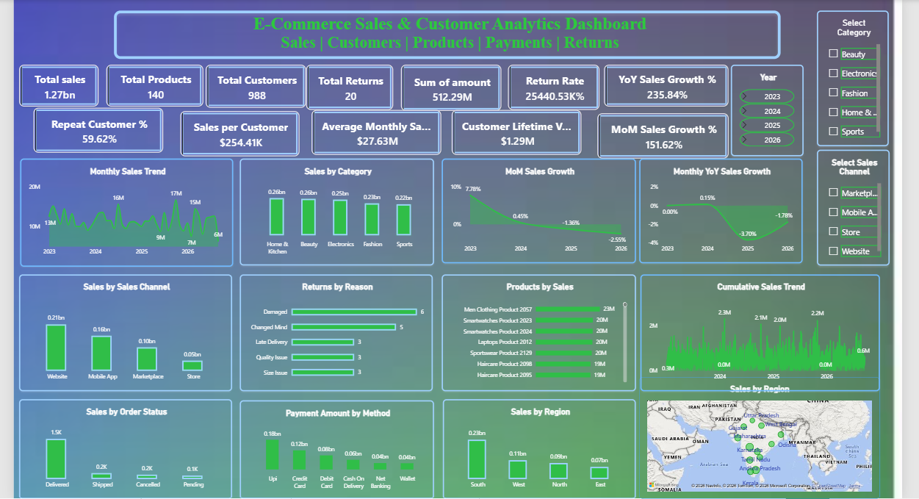
DASHBOARD

